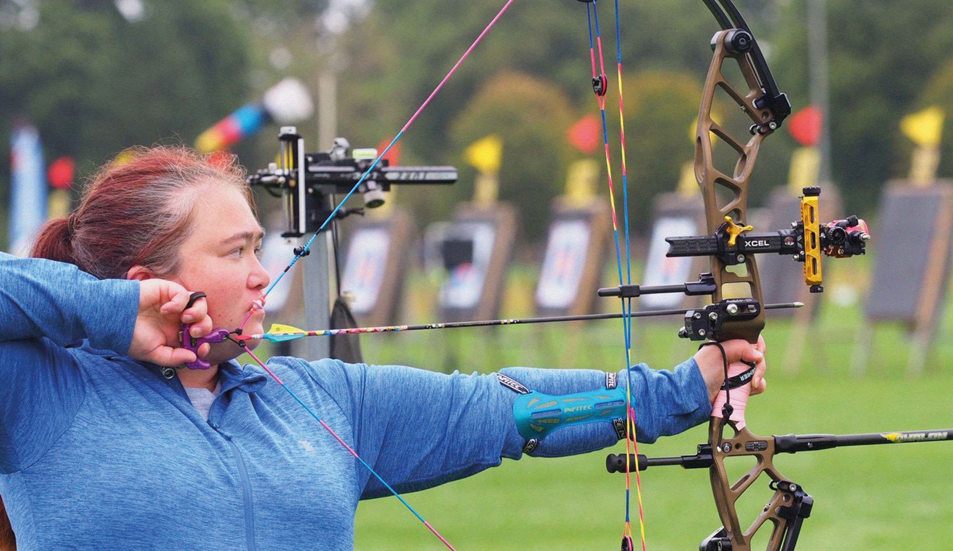






Annual Public Meeting
2025

Registered charity number: 222798

Our values :

Compassionate and Caring
Inspirational

We provide high quality services delivered with compassion through relationships based on empathy, kindness and dignity.
We recognise achievements.
Vibrant
We are positive in our actions.

Respectful
Excellence

We treat others as they would want to be treated, with dignity and respect.
Enabling

We empower those people living with a sensory loss to live independently, achieve their goals and exercise choice.
Ambitious

We are innovative, flexible, dynamic and passionate.
Trusted

We are experienced, knowledgeable and professional.
We strive for high quality in everything we do.

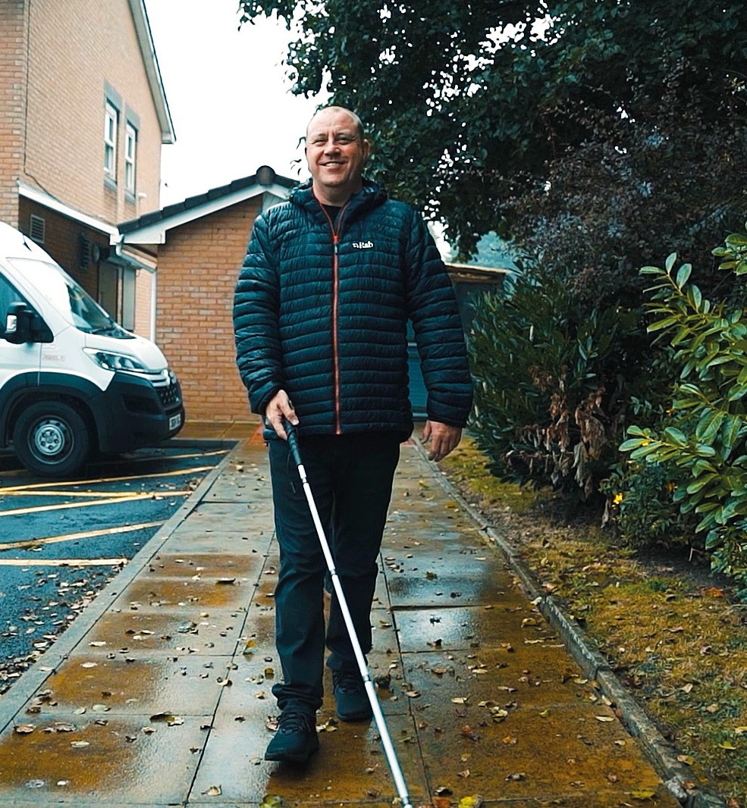
Treading the right path

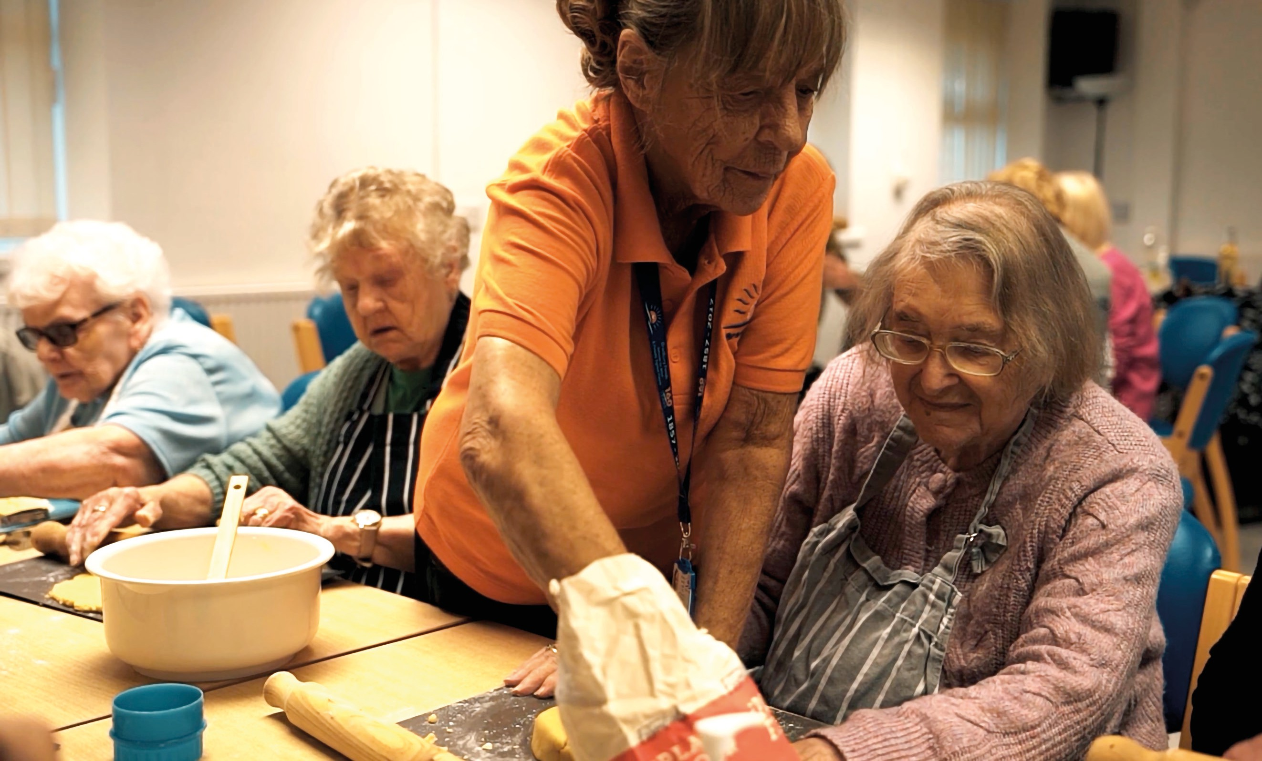

In the mix at Bradbury Fields


Contents
- Welcome from Chair
- Meet the team
- Reflections of Chief Executive
- Social Impact Statistics – Health & Wellbeing
- Some of our life-changing stories…
- Report of the Trustees and financial review
- History of Bradbury Fields
- Supporting the future of Bradbury Fields

Welcome from Chair

I have been a trustee of the Bradbury Fields board since early in 2025. I have worked in the criminal justice arena for over thirty years and will be leaving this post at the end of this year. I am excited to now be in a position to channel my energy into this organisation. I have lived experience of visual impairment and hope to make a positive contribution, promoting
the Social Model of disability and working hard to remove barriers for visually impaired individuals. It is the obstacles we encounter in our lives that disable us, rather than our impairment.

We have recently benefitted from expert advice to explore ways in which we may enhance service provision and raise the profile of Bradbury Fields. We already have
a fully committed team of staff and dedicated trustees working hard to deliver existing services to the visually impaired community in Liverpool, Knowsley and surrounding areas. We hope to develop new activities and projects in the next twelve months, in order to reach others across the city region and beyond.
We plan to focus on sustainability of existing activities and the development of new creative PROJECTS during 2025/2026,
forming partnerships with other local statutory and voluntary sector groups. It is envisaged this will broaden the Bradbury Fields service user community, in order to enhance emotional wellbeing of those individuals and increase access to mainstream opportunities as well
as disability led projects. We HOPE to increase unrestricted funding to do so and are keen to increase the staff and volunteer teams to facilitate this. I know I speak on behalf of all those on the board of trustees, in expressing thanks for the ongoing contribution of all those involved in Bradbury Fields.

I look forward to participating in the growth of the organisation in the next twelve months.

Gill Wake, Chair
October 2025


Reflections of Chief Executive

Although this is for our annual public meeting, it would be remiss of me not to acknowledge the fact that this is our first annual public meeting for more than 5 years, this of course owing to a number of factors, not least of all the Covid-19 pandemic and our merger and de-merger with CBI.

Bradbury Fields – services for blind and partially sighted people was first established in 1857, since which time many people have contributed so much, in so many ways. For that we are eternally grateful.

I would like to extend my heartfelt thanks to all of those who have supported us this year and over the last 5 years. I include our trustees, our diligent and dedicated staff, our fantastic volunteers, together with so many other stakeholders, partners, donors and supporters. This year we have seen many of our service users taking to challenges in support of our fantastic cause, these ranging from sponsored walks and triathlons, to abseils and sky dives. One of my personal highlights of the year is
our Bradbury Fields annual Christmas Market, which truly does bring our Bradbury Fields community together.

As an organisation we strive to make a difference in the lives of local people living with sight loss. With your continued support we can help people to adapt and adjust following the onset of their sight impairment and to embrace opportunities to help in gaining, or regaining, confidence and achieving their level of independence.

When you read the service user stories below, you will see how the excellent work of Bradbury Fields really does enable blind and partially sighted people to live more fulfilled lives. It should be no surprise that so many of our service users, and their families, will shout from the roof tops about the positive impact we have, and the great work we do.

We maintain strong relationships across the local authorities for Liverpool, Knowsley and Sefton, together with Liverpool University Hospital Foundation Trust (LUHFT). I would like to thank all of these organisations for their commitment to a collaborative and proactive approach to services, these being focussed on Vision Rehabilitation and Eye Clinic Liaison services.

I invite you all to spare a moment to remember some of our former, longstanding colleagues, who have sadly passed away in recent times, these being Frank McFarlane, Jamal Abdullah, Margaret Guppy and Jim Moran.

If I was to quote The Usual Suspects, tickling the ivories, our very own karaoke king or our storytelling baker of cake, many of you would probably be able to conjure a fond memory or two. Whilst we have lost these unforgettable characters, their dedication to our cause and the legacy
of what they have helped Bradbury Fields to achieve lives on, with a collective service to sight loss between them of more than 100 years.

We have seen so many successes this year, many of which are team efforts. These have included projects such as “What is Blindness” which saw many of our staff, volunteers and service users engaged in a creative project alongside a number of partner organisations including local universities. We are so very pleased to receive the success of 4 years of additional Reaching Communities, national lottery funding. This too was a team effort but was made very much more achievable following the previous 3 years of meaningful and impactful delivery.

Whilst it is difficult to single out any volunteer, as each and every one is so vital to us, I wanted to congratulate our Inspirational Voices choir team, and more specifically our Choir Leader Tim who was recently awarded the BBC radio Merseyside, Make a Difference Volunteer award for his work with our choir. Our choir, now more than 10 years old, continues to go from strength to strength and is a great place to be on a Friday morning in our lounge. Truly uplifting.

I would conclude by saying that being a charity does not come without its challenges, however you will see from the contents of this pack that these challenges are outweighed by the reward of positive impact. I believe
we are in a strong and stable position, ideally placed to work towards a sustainable future. I am genuinely excited to build on this with our wonderful team here at Bradbury Fields.

From the bottom of my heart I thank you all.

Matt Cliff, Chief Executive Officer
October 2025

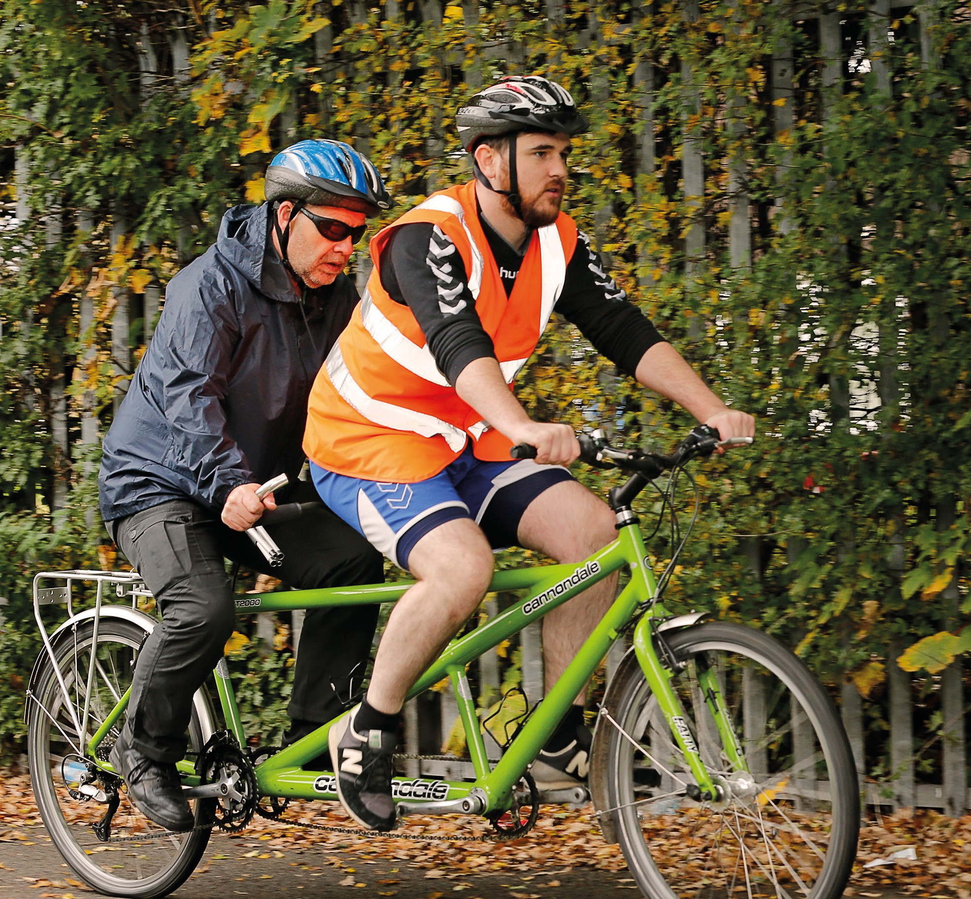
Two cyclists finding the Bradbury way

Meet the team

Board of Trustees

Richard Cole
Gill Wake
Chair
Geraldine Bounds
(Deputy Chair)
Jean Collins
Matt Hughes-Paton
Treasurer
Julie Lee Angela O’Brien Roger Phillips Tudor Roberts

Staff team

Donna Healey-Sharpe Deputy CEO / Rehabilitation Services Manager
Matt Cliff
Chief Executive Officer

Operational Management Group (OMG)

Andie Griffiths
Health, Wellbeing
and Volunteer Coordinator

Dawn Hargreaves
Finance Officer

Glen Flatley
Trusts and Foundations Fundraising Lead

Jess Bowie
Buildings and Maintenance Manager

Karen Brake
Head Chef / Catering and Events Manager
Louise Miller Community Fundraising Coordinator



Rest of the Team

Julie Ambrose
Eye Clinic Liaison Officer

Maria Annibale-Schofield,
PA to Chief Executive

Emma Birchall
Rehabilitation
and Technical Assistant

Sophie Brake
Kitchen / Catering Assistant
Lynn Bowie Advocacy and Welfare Benefits Advisor
Tracy Duffy Housekeeper / General Assistant

Lorraine Edwards
Receptionist

Kim Eyres
Active Vision Clubs Coordinator

Marie King
Lifestyle and Rehabilitation Assistant
Kathryn Leech Rehabilitation Officer for the Visually Impaired

Jane Lewis
Equipment & Registration Officer / Receptionist

Jane Litherland
Eye Clinic Liaison Officer

Marie Messin
Senior Rehabilitation Officer for the Visually Impaired

Vivienne Middleton
PA / Equipment
and Registration Officer
Curtis Miller Rehabilitation Officer for the Visually Impaired

Vicky Murray
Kitchen / Catering Assistant

Lisa O’Malley
PA / Support Worker
Dawn Scott Rehabilitation Officer for the Visually Impaired

Corinna Swift
Eye Clinic Liaison Officer

Loraine Stuart
Administrator

Paul White
Rehabilitation Assistant

Social Impact Statistics

Health & Wellbeing

In addition to the statutory services we provide, we also offer a range of health and wellbeing activities to help people enjoy life after sight loss.

Our Be Active Service provides volunteer support to ensure people can attend group activities in the community. Activities include; swimming
and gym sessions, braille group, choir, tandem cycling and walking groups, baseball, cricket and goalball, let’s talk group, somatic gentle exercise, yoga, artful crafts and crochet.

Active Vision is the name for our daily social activities’ clubs. Based at the Bradbury Centre, people with sight loss come together to make friends, find peer support and to enjoy a wide range of centre-based social and leisure activities. As part of our Active Vision Clubs (AVC), we also provide catering, entertainment and transport.

We note below some key statistics from a social impact evaluation of our Health & Wellbeing services spanning a period of 3 years to March 2025.

For every £1 invested in the project we calculate that £9.27 of social value will be created.

Jobs: 4.9%
This is broken down as follows:
Volunteering: 7.4%
Independence &
self-confidence: 14.7%
Health and wellbeing: 37.1%
Social isolation: 33.2%
Minibus transport: 2.7%

Additional service user interviews findings:
Total attendance at Active Vision Clubs was 8,836 over the three years.
In Year 1 (2022/23) average weekly attendance was 63.2, increasing to
72.0 in Year 3 (2024/25).

Be Active activities | Health & Wellbeing | Achieved improved
total attendance was | services generated | mental and physical
15,001 over the three | 20,297 volunteer | health, and reduction
years, an average | hours. | in social isolation for
weekly attendance per |  | 197 regular service
activity of 7.9. |  | users.

93% of Be Active and 92% of  AVC stated that they would not have felt more confident, if it wasn’t for this programme.  91% of Be Active and 99% of AVC stated that they would not have met new people, if it wasn’t for this programme.  77% of Be Active and 75% of AVC state they would not have become more independent if it wasn’t for this programme. | 89% of Be Active and 90% of  AVC stated that they would have felt less socially isolated if it wasn’t for this programme.  69% Be Active and 50 AVC stated they would not have gained new skills.  90% Be Active and 90% of AVC would have not had improved mental health and wellbeing.  79% of Be Active and 55% of AVC would not have had improved
 | physical health and wellbeing.

Some of our life-changing stories…

Our rehabilitation services across Liverpool and Knowsley have both faced some challenges this year, with the national shortage of specialist staff making recruitment a very difficult challenge. This has however been overcome in both areas with a small number of subcontracted hours from our partner agency Guide Dogs. We have recognised this as a short-term solution so have focused on in house training and will have a newly qualified Vision Rehabilitation Specialist in each of the teams by the end of 2025.

Our focus remains how to deliver the best possible service in the timeliest manor. To do this we have had to recognise the increased demand for service and the complexity of the cases coming through, and also to make changes to our working practices to be more effective and efficient. We have achieved a big step forward in the past year, reducing our waiting time by 50% from an average of 10 to 5 months.

Whilst doing this we have also listened to what our service users want from us and have increased our offer of group-based activity by
supporting Information Technology groups and by delivering our new air fryer cooking courses which have been very well received.

Although we have made good progress this year, we are mindful that there is still progress to be made and we strive to keep making those changes to improve the service we provide.

Our goal for the coming year is to be fully staffed in both teams; to take a special look at the
demographics of our service users we are not fully enough offering a service to, the school leavers and those of working age for example. We will be moving forward to look at how to provide a wider range of groups and activities outside the 9 to 5 working day and in the areas, we cover outside of our centre base.

We hope that the following successes show at least in some way why our services are so important and why it is so important to recognise the
great work of our team members across Bradbury Fields, both front-facing and not, and why
it is such a privilege for us to be able to help these services develop and grow.

Service user A

Service user A was registered Sight Impaired (SI) in September 2024. This was a shock for them and their family. Before the referral was sent over to Bradbury Fields our Eye Clinic Liaison Officer which is often the first point of contact for people with a recent diagnosis offered advice and emotional support and discussed what services were available.

Service user A works full time and has managed to deal with the challenges and come to terms with their sight loss while maintaining their employment. After being diagnosed with Acute macular neuronopathy, an assessment was completed with
one of our qualified rehabilitation officers, there were several areas of concern for service user A, the focus for them was to be able to still get to work independently and continue to do their job.

The long cane process was started and the rehabilitation officer also supported service user A to ask for reasonable adjustments at work to allow this training to take place each week. Once service user A had successfully completed routes during the daytime and
they had gained in confidence
our rehabilitation officer delivered training in early evenings to ensure service user A was confident in dealing with the seasonal changes of darker evenings.
The rehabilitation officer also supported with setting up changes to their home working space, making it as accessible and comfortable as possible. This included support with changing
font sizes and training on new ways of working, which could be carried forward to the office workspace.
Office glare due to overhead lighting could not be changed, so a filter assessment was then
completed to allow service user A to have specialist glasses to wear to protect them from this.
While this work was on going the rehabilitation officer also helped service user A to look at
their social time and how to keep enjoying this, but they felt this was a waste of time due to their hobby being arts and crafts, which they could not see any more. A repurposed (donated to Bradbury
Fields) CCTV was issued to service user A to make these hobbies accessible again.
As confidence grew it allowed them to consider what else might be possible and more in house

skills were also developed with service user A now cooking for themselves again.

This programme of training has taken a year due to its complexity and work commitments but now service user A feels that life is
full again and has even joined the England Blind Archery team.
“With a big thank you for helping me get back on my feet, I was able to meet new friends and get back doing something I really like doing.”

She has since come first in a novice tournament and 2nd in the overall tournament for Archery.

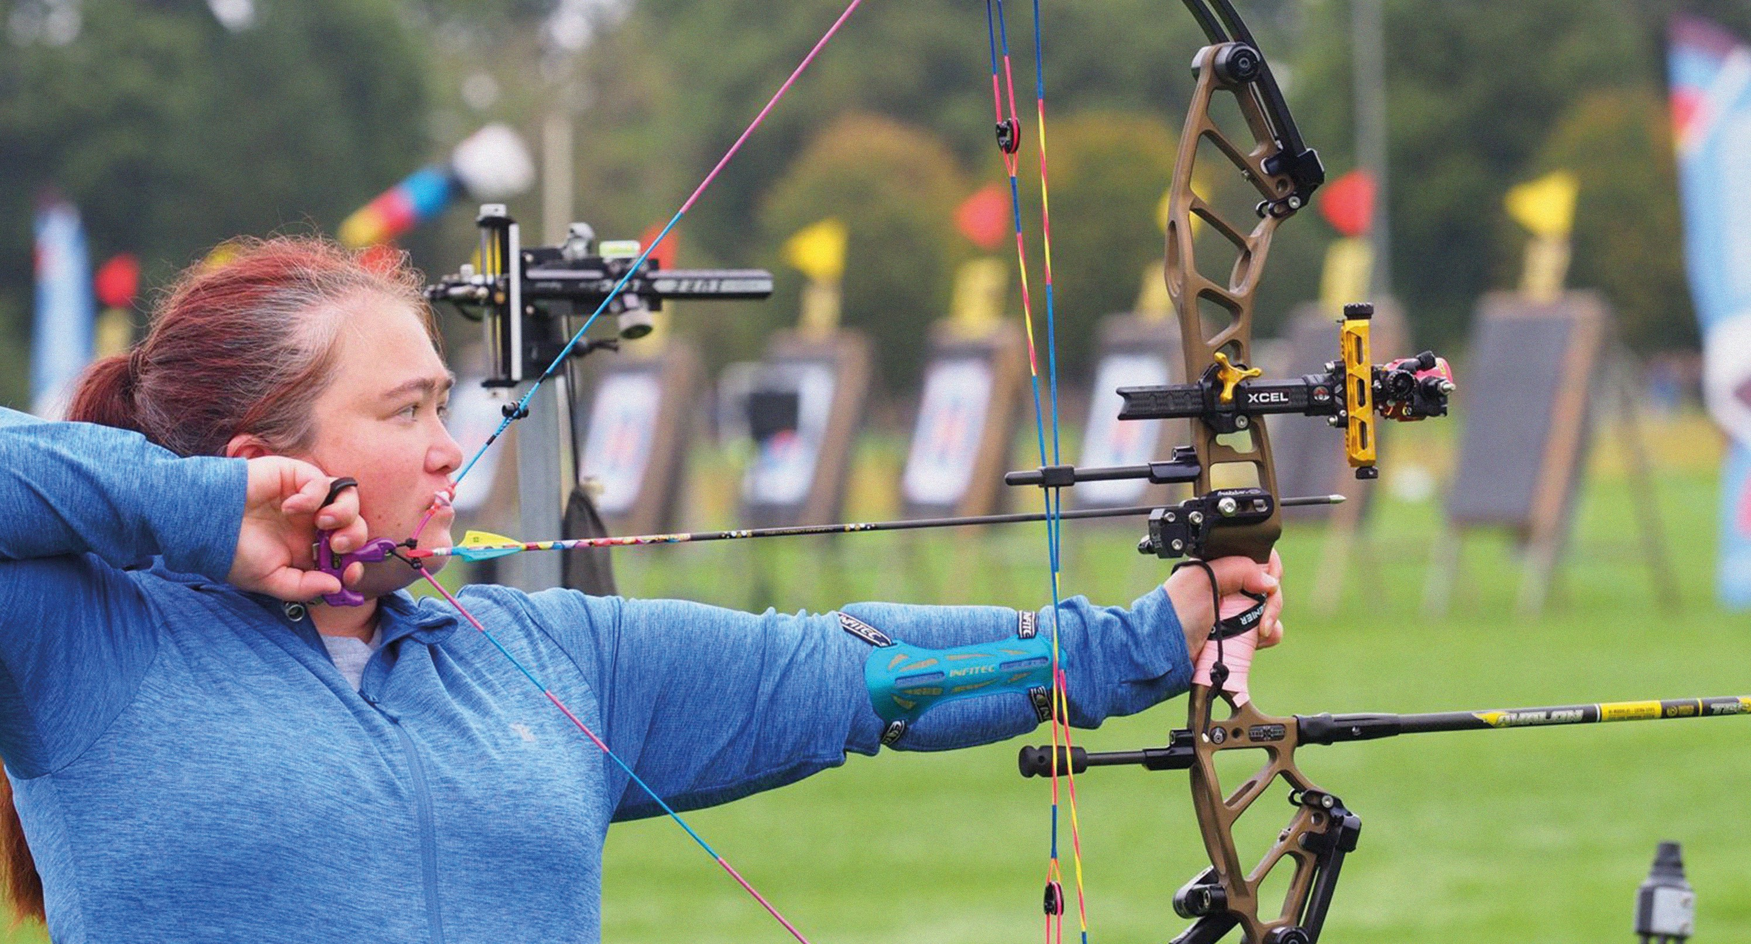

On target with England Blind Archery team

Service user D

Service user D was registered Severely Sight Impaired (SSI) in 1998, so had been known to the service many years ago, he did not feel that we could do much to support him at home due to his poor health and mobility, which had got worse since he had lost his guide dog. He was feeling very isolated,
so our rehabilitation worker encouraged him to attend our centre and try some of the wellbeing activities, he agreed to try this.

We have since seen remarkable progress in Service User D since they first began attending our
Be Active wellbeing programme.

Initially, they joined us at our weekly coffee morning. At that time, they were very quiet, hesitant to engage in conversation, and relied on a wheelchair for mobility.

Soon after, they began attending our Talk Group session and gradually started forming new friendships.
Over time, they became a regular attendee at both the coffee morning and the Talk Group and began expressing interest in other activities offered at the centre.

The transformation in Service User D’s confidence and happiness
has been lovely to see. One of the most significant changes has been with their mobility, as they have progressed from using a wheelchair, to a walker, and now, they only require a walking stick. They have shared with us that they credit this improvement to having found a sense of community, purpose, and increased activity at the centre.

Prior to joining Bradbury Fields, Service User D had spent ten years isolated at home. Now, they attend a wide variety of sessions each week, including the Active Vision Club, Let’s Talk, Music Appreciation, Tech sessions, and swimming and gym sessions.
Recently, Service User D joined us for our social evening, their first night out in over a decade, which
was an incredible milestone, and it was lovely to reflect with them
about the progress they have made.

Their story is a great example of the positive impact that community, connection, and accessible wellbeing activities can have on an individual’s life.

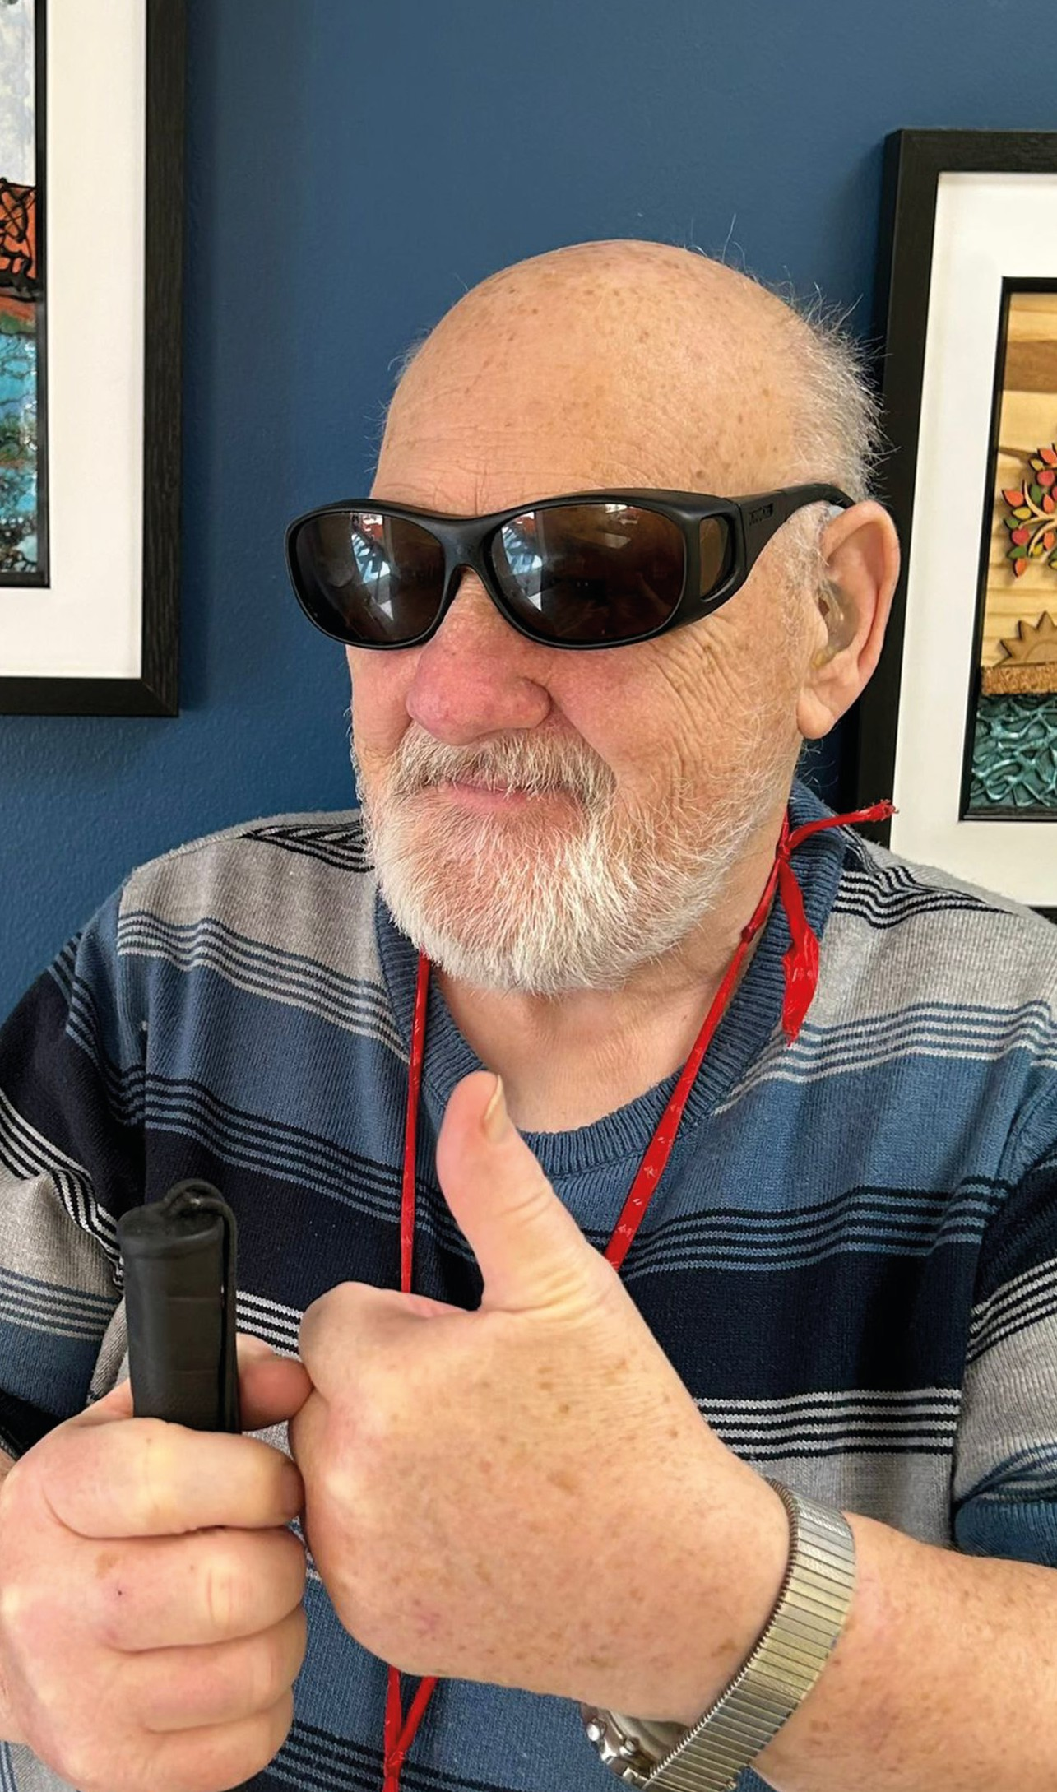
He is now going to look at developing some of his other skills as he is now interested in improving his IT skills and wishes to learn to touch type to be able to use his computer again.
Confidence and happiness

Service user H

When Service user H was referred to the Knowsley team in January 2025, they were struggling to come to terms
with his recent diagnosis of age-related macular degeneration (AMD) and being registration as sight impaired (SI).

The impact on his daily life had been profound, but perhaps the most heartbreaking loss was the abandonment of their greatest passion – art.

For two years, service user H’s paintbrushes had been untouched, his canvases gathering dust. The talented artist who had once created detailed works with confidence found themselves unable to see
well enough to continue the hobby that had brought them so much joy and fulfilment. They became very withdrawn, and their mental health had begun to suffer.

Following a full visual impairment assessment, service user H
was provided with specialist task lighting and magnification
equipment tailored to their specific needs, along with techniques to maximise their remaining functional vision.
The transformation was remarkable.

With the right support and adaptive technology in place, service user H picked up his brushes once more.

“I never thought I’d be able to draw or paint again,” service user H shared. “The team didn’t just give me equipment – they gave me back a part of myself I thought I’d lost forever”.

Today, service user H is creating art once again, adapting their techniques to work with their sight loss whilst maintaining the passion and skill that defined them as an artist.
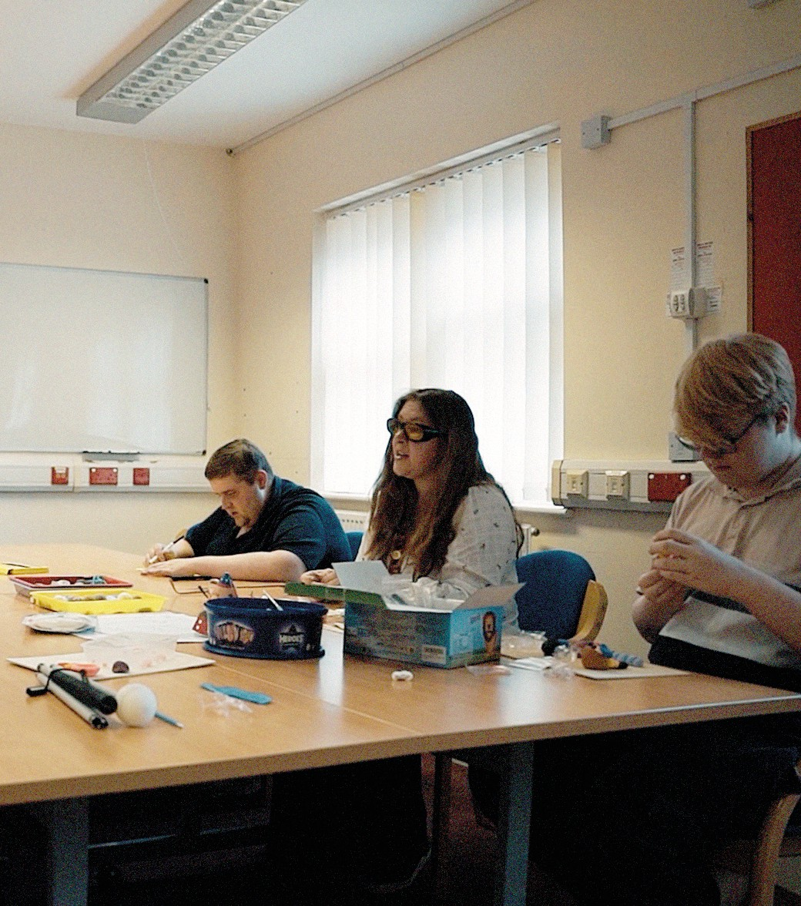

Creating again

Service user T

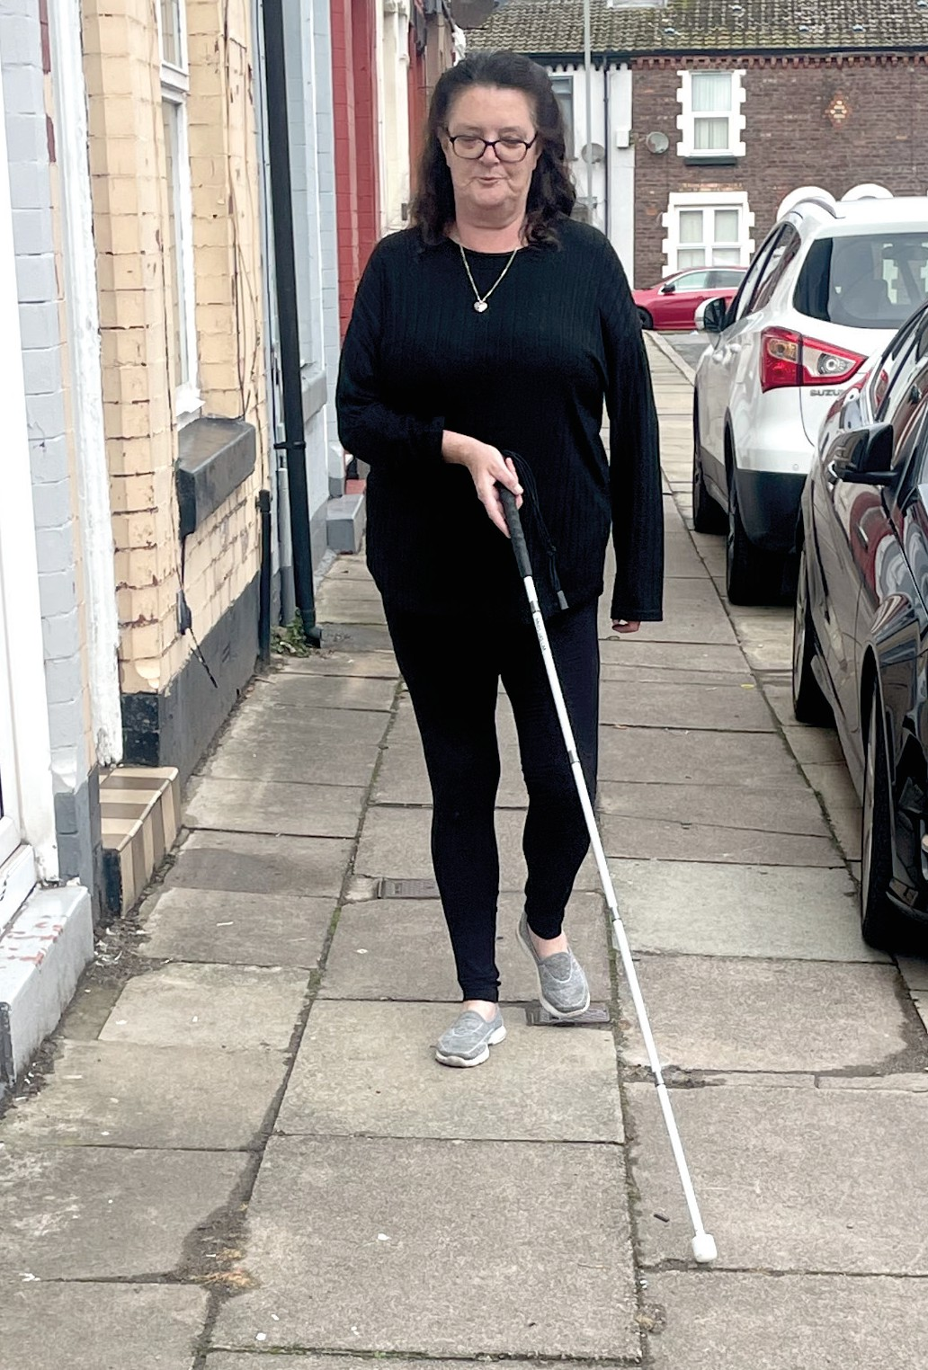
Service user T worked as a qualified nurse when they started to have problems with their sight and had to leave work when diagnosed with Glaucoma. This led to a rapid sight decline and them being certified as Severely Sight Impaired (SSI) in October 2024.
“Thanks for the support”

Their rehabilitation assessment took place before the end of the year and a lot of areas of need were highlighted, the most obvious of which was the emotional impact that their sight loss was having leading to statements like “life has no purpose anymore”.

The priority was a counselling referral while other areas of support were looked at. Our Advocacy and Welfare Benefits Advisor offered support to apply for benefits as service user T was now out of work. Benefits and concessions were sorted relatively quickly with them all in place including Personal Independence Payments by June this year.

Service user T had lost independence in most aspects of their life in a relatively short space of time. They felt they could no

longer prepare drinks or food for themselves, communicate with others in writing or by phone, read what they wanted or go out to do simple tasks like getting money from the bank.

So, due to the input and support of one of our qualified rehabilitation officers and supported by our trainee rehabilitation worker, the interventions were wide ranging.
Pouring skills were taught with the importance of colour contrast. The implementation of task lighting

helped to make spot reading possible again. Introduction to technology and what their phone could do allowed independent access to friends and family again, and to allow them to enjoy books once more.

Upon successful completion of the counselling course, service user T was ready to face going out, so the long cane training process started. This is a long process that is hard work and takes a lot of commitment. This training took around 6 months
to complete with at least one session per week.

Service user T is now able to get out of the house and visit places they want to go to independently. During a recent review with our now newly qualified rehabilitation officer, service user T thanked them for all their support because now they are ready to start a new journey, that of getting themselves back to work.

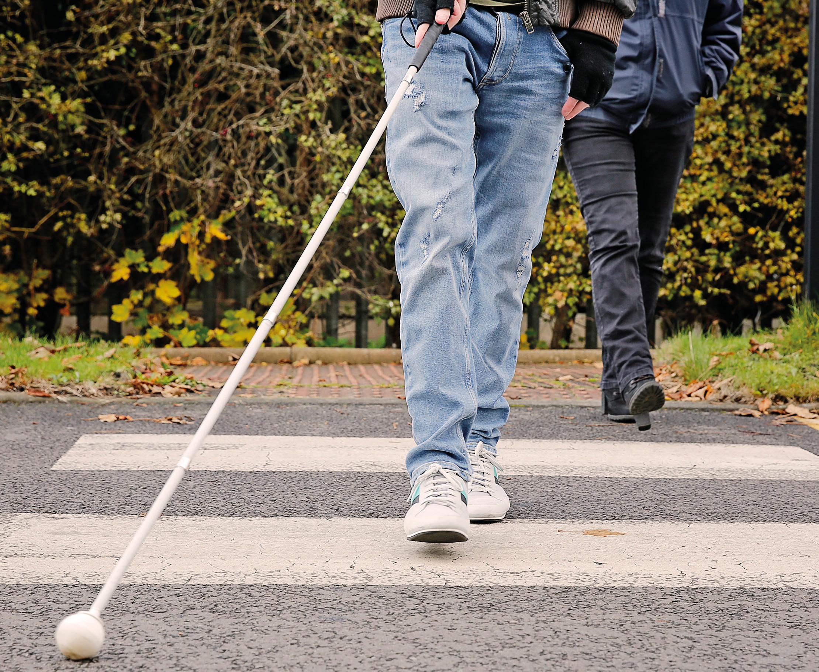
Long cane training - 6 months and lots of hard work

Report of the Trustees
for the Six Months ended 31 March 2025

Bradbury Fields-Services for Blind and Partially Sighted People is a registered charity, incorporated as a company limited by guarantee. The charity registration number is 222798 and the company registration number is 00654873.

Objectives and activities
Our Vision is: | Our Mission is to:
A world in which those | Enhance the quality of
people living with | life and promote the
sensory loss can | health and wellbeing
flourish. | of people living with
 | sensory loss.
Since 1 October 2024, this company has reverted to operating as an independent charity, separate from Catholic Blind Institute. The trustees believe this safeguards the future of the excellent services that we provide, will improve the efficiency of our organisation and - by returning to having our own governing body - will enable greater focus on the core activities of the charity. We began the year with sufficient reserves to ensure a stable position, and a pathway to delivering vital services over an extended period. The trustees now hope that the charity can flourish, to protect the users of our services.

The Bradbury Fields charity delivers rehabilitation services, information and advocacy, peer support groups, and Eye Clinic Liaison Officer services to support and enhance the health and wellbeing of up to 5,000 people. This number is the approximate number of people registered with a visual impairment in Liverpool and

Knowsley, the areas of Merseyside we predominantly serve.

However, advice and signposting are available to all, if This then further enables us to help people who are visually impaired.

Service provision extends to those adults who develop sight loss in later life so they can learn and implement new skills to assist them in managing their lives in their changed circumstances.

The strategies employed to achieve our service objectives during the year were to:
- Secure long-term funding from local authorities and health bodies
- Promote volunteering across the organisation
- Promote legacies and trusts
- Maximise the income potential of the Bradbury Centre
- Develop other income streams to enhance, promote, and develop opportunities for people with lived experience of sight loss
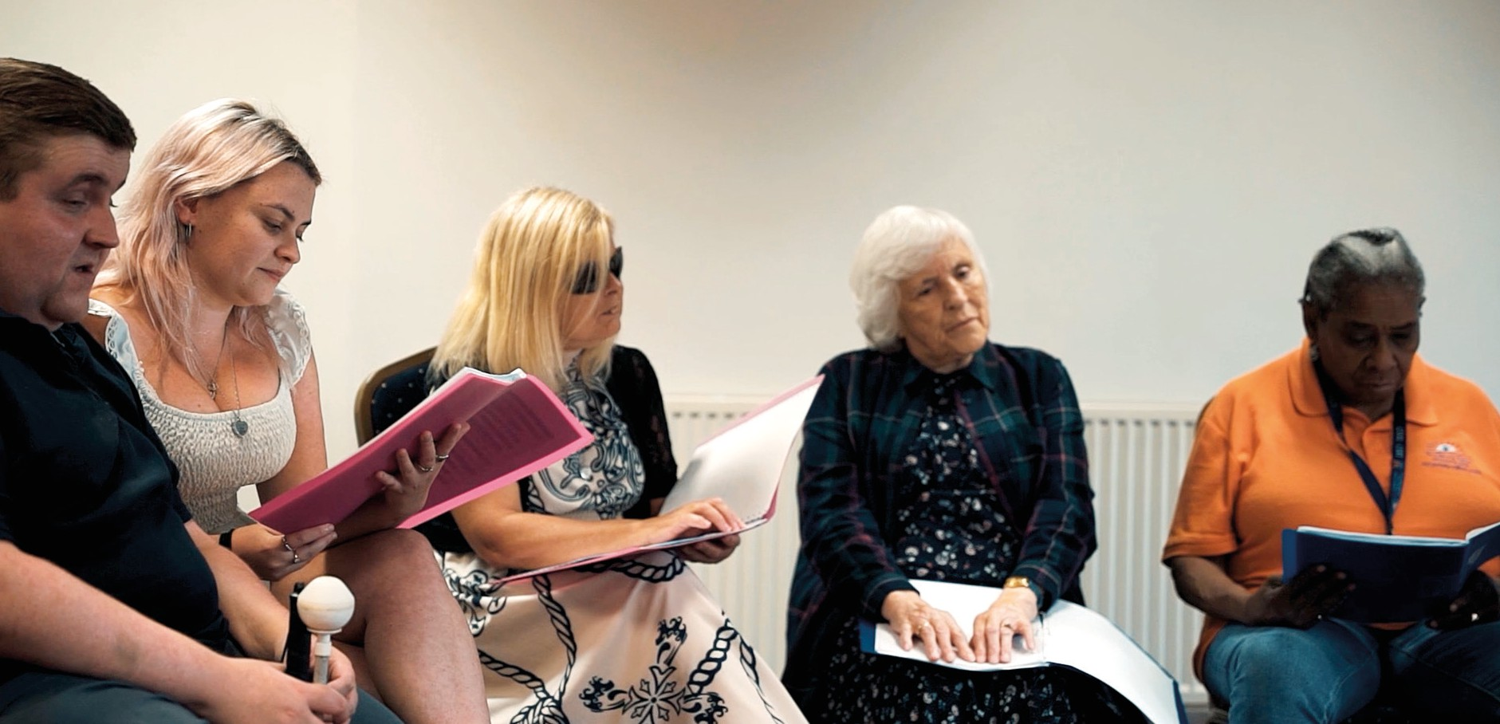
- Encourage and enable innovation

Choir practice

Achievements and Performance
During the reporting period we have continued to offer a first-class service to our many service users. We have done this through providing support at the point of diagnosis within our hospitals; through Sessional Rehabilitation Support in teaching new skills and encouraging confidence building; through the delivery of Active Vision Social Clubs; and through providing both individual and group support through our Be Active service, to break the sense of isolation and loneliness associated with sight loss.
Our emphasis is around health and wellbeing support.

Our visual awareness training also remains a service that people find extremely useful, educational, and fulfilling.

Our activities are many, some of which are listed below together with statistics covering the period 1 October 2024 to 31 March 2025:

© Adult Referrals: 410  © Children’s Referrals: 11  © Adult Assessments: 274  © Children’s Assessments (Knowsley only): 5  © Children’s Habilitation sessions (mobility only): 18  © Adult Rehabilitation Sessions: 876  © Activities of  Daily Living (ADL): 185  © Mobility: 218  © Communications: 163 | © Assistive Technology: 60  © Low Vision  Assessments (LVA): 138  © Reviews 47  © Total number of pieces  of equipment issued: 595  © Benefit Support  © Number of  people supported: 88  © Total increase in  annual incomes: £263,782  © People supported  by ECLO’s: 1157

We would like to acknowledge and thank the funders, donors and other supporters who have helped us maintain Bradbury Fields through this period.

Key partners including Liverpool City Council and Knowsley Borough Council have, through their commissioners, been extremely supportive, which has enabled us to continue to meet the requirements of our statutory contracts.

We are also grateful to The National Lottery, who have extended their support to our Health and Wellbeing activities for a further four years. We would like to thank our many community supporters, whose contributions are never taken for granted.

We would also like to thank all those who work for us, either as paid staff or volunteers. As ever, we want them to know how hugely valued they are by the board of trustees and, indeed, by our service users.

Financial review
As stated above, since 1 October 2024 our services have been delivered through this company.

Our accounts reflect the opening position for Bradbury Fields on 1 October 2024 (following separation from Catholic Blind Institute at 23:59 on 30 September 2024), and our results for the 6 months to 31 March 2025.

There was a deficit for the 6-month period of £3,160. Income for the period was £574,879.
Expenditure for the period was £578,039.

As a result of these movements, funds held at the year-end totalled:
Unrestricted Fund £1,283,483 Restricted Fund £57,873.

Financial review (continued)
The key figures are shown below comparing the period ended 31 March 2025 with those figures from the previous period to 30 September 2024.

 | 2025 |  | 2024
 | £ |  | £
Income | 574,879 |  | -
Expenditure | 578,039 |  | -
Deficit | (3,160) |  | -
Bank & Cash | 495,26 |  | 445,473
Net Assets | 1,341,356 |  | 1,344,516

Reserves policy
The trustees overall aim of the reserves policy is to cover total expenditure for a period of three months which is predominantly to cover salary costs and, also, to cover ad-hoc maintenance and capital expenditure which occurs outside of board approved budget costs.

Although the balance sheet shows that there were total unrestricted funds of £1,283,483, as at 31 March 2025, of which £832,932 represents unrestricted fixed assets and investments, none of which is available
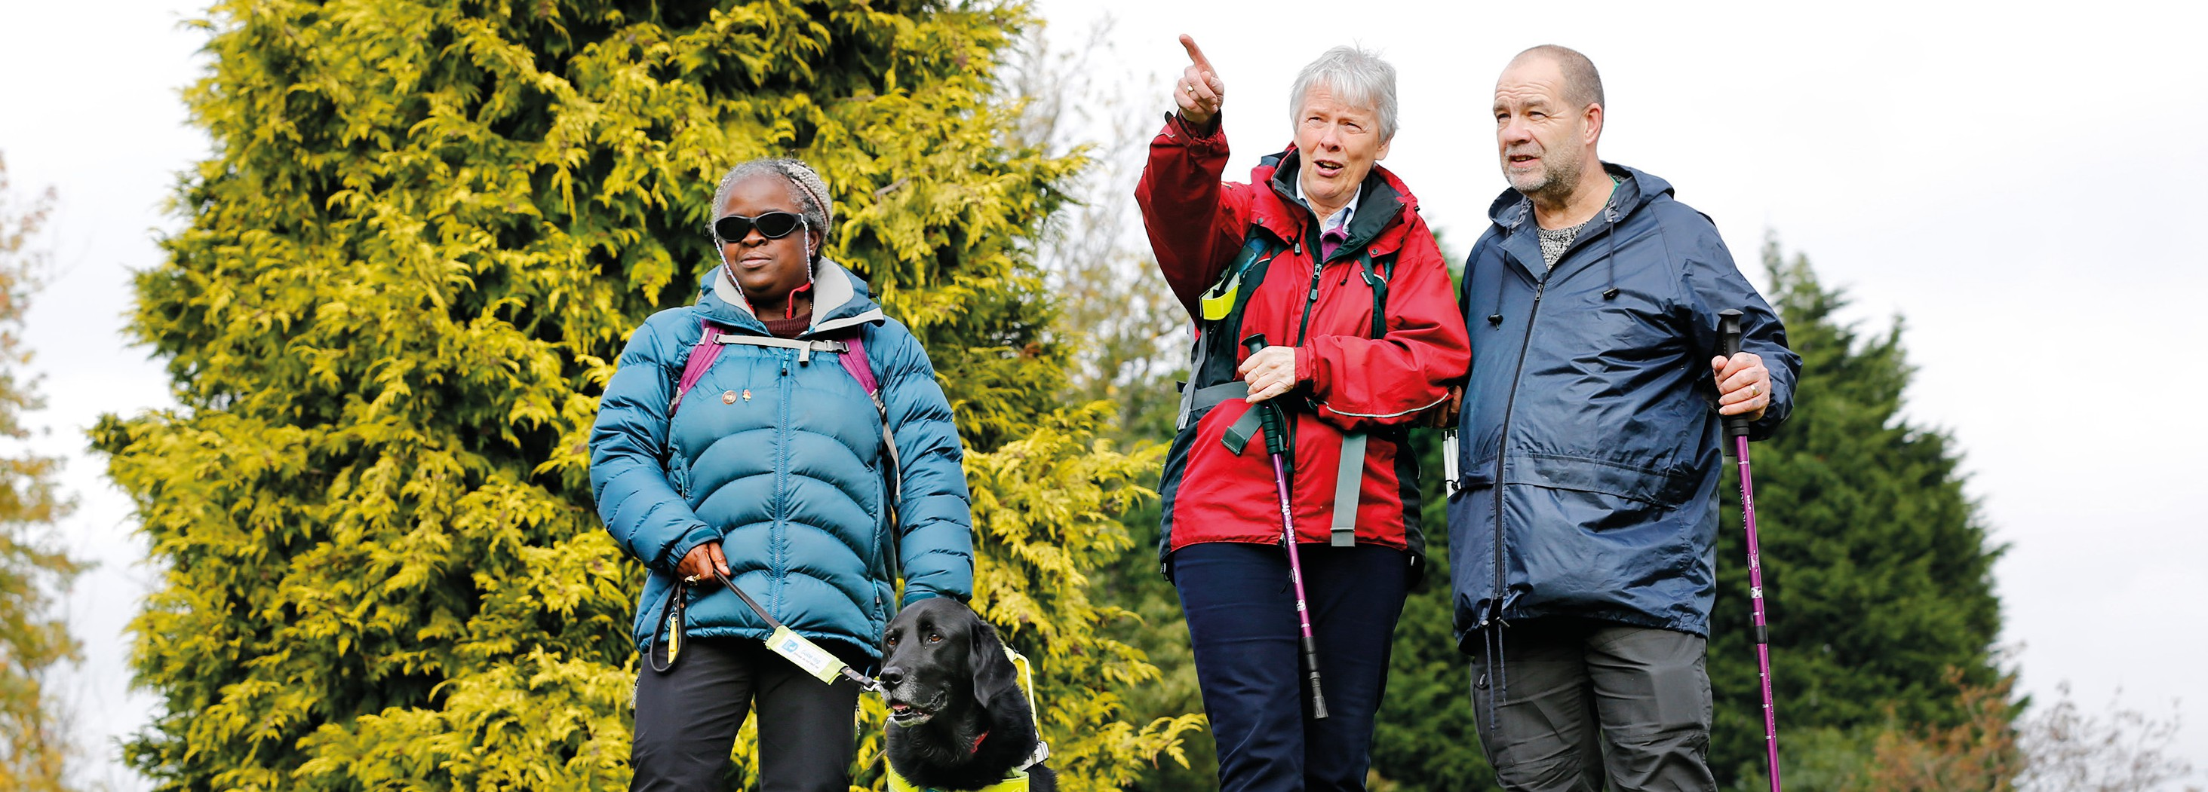
to the trustees to defer ongoing running costs. This leaves £450,551 free expendable reserves which equates to approximately 7 months of unrestricted expenditure.

Volunteer support for group activities in the community

Plans for the future
The trustees have referred to the advice contained in the Charity Commission’s general guidance on public benefit when reviewing our aims and objectives, and when planning future activities. The trustees have considered the specific public benefit guidance relating to the advancement of health, and the relief of those in need by reason of disability.
© We strive for an ethos of continual improvement.
© We focus on learning from both positive and negative experiences alike, ensuring that we listen to those living with sight loss.
© We aim to enhance our offer for:
h Assistive technology training.
h Learning and volunteering opportunities.
h Peer and social support groups.
h Sports and physical activities.
h Use of both mainstream and specialist smart and communication technology.
© Not only do we want to offer a sensory loss service that is
sector-leading, but we also want our centre to remain busy, vibrant and bustling with energy and we want to be engaging with service users within community settings too, working collaboratively with like-minded people and organisations.
© We continue to review our services on an ongoing basis to ensure we meet the needs of our users in the modern ever-evolving world.
Amongst other things, we are excited for the upcoming launch of our kitchen skills sessions utilising both specialist and mainstream air fryers and other kitchen equipment.
© We are committed to working efficiently and ensuring best value at all times.
To support the above objectives, we have spent considerable time, in this period, considering our marketing and fundraising strategies, seeking external advice on the latter, and comparing our own fundraising strategy

to that of our peers. Based on this research, we will be increasing our investment in Trusts and Foundations fundraising. We have also sought specific advice on our Legacies strategy and, based on this and our wider research, hope to launch a Legacies campaign in our next accounting period.

We are also looking to recruit a small number of additional trustees, to enhance the skills of our board.

Local visually impaired people can rest assured that our priority is to do what we can to improve their lives.

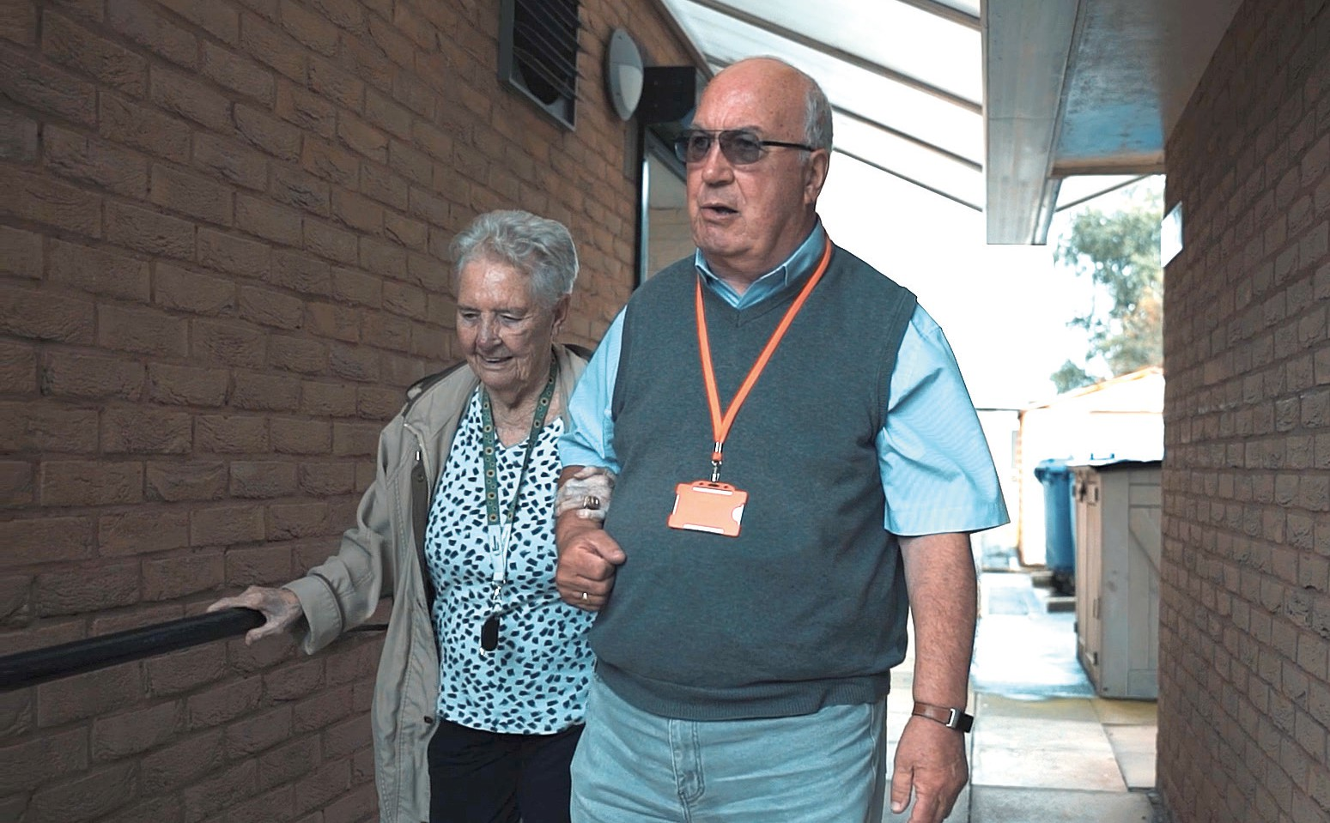
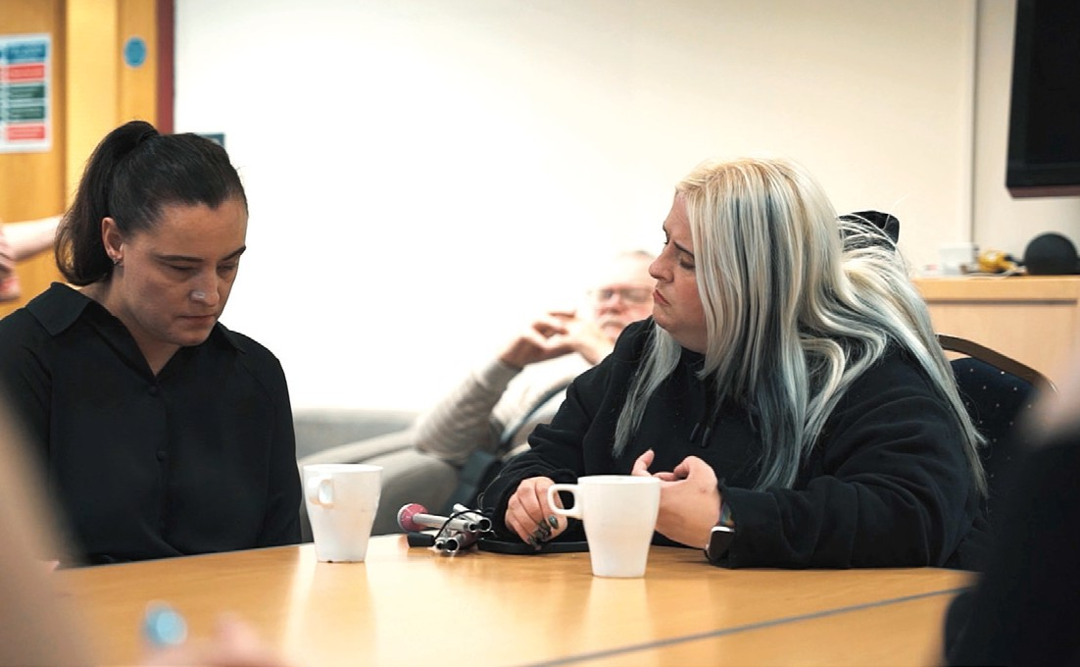
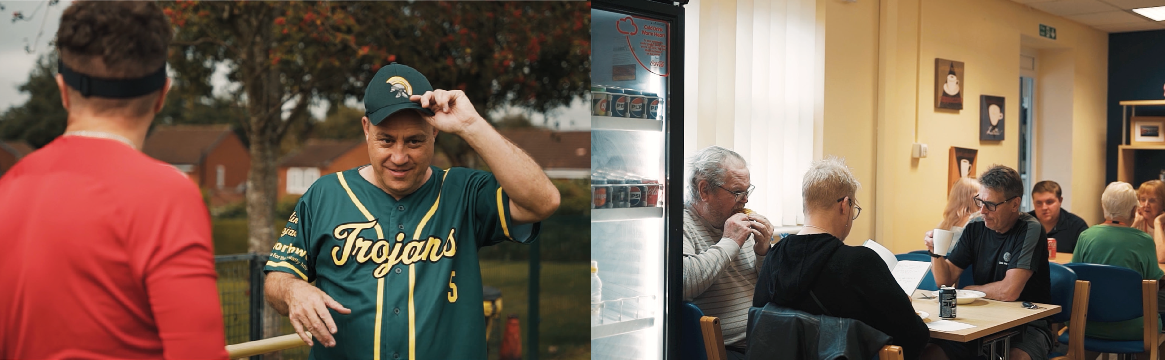
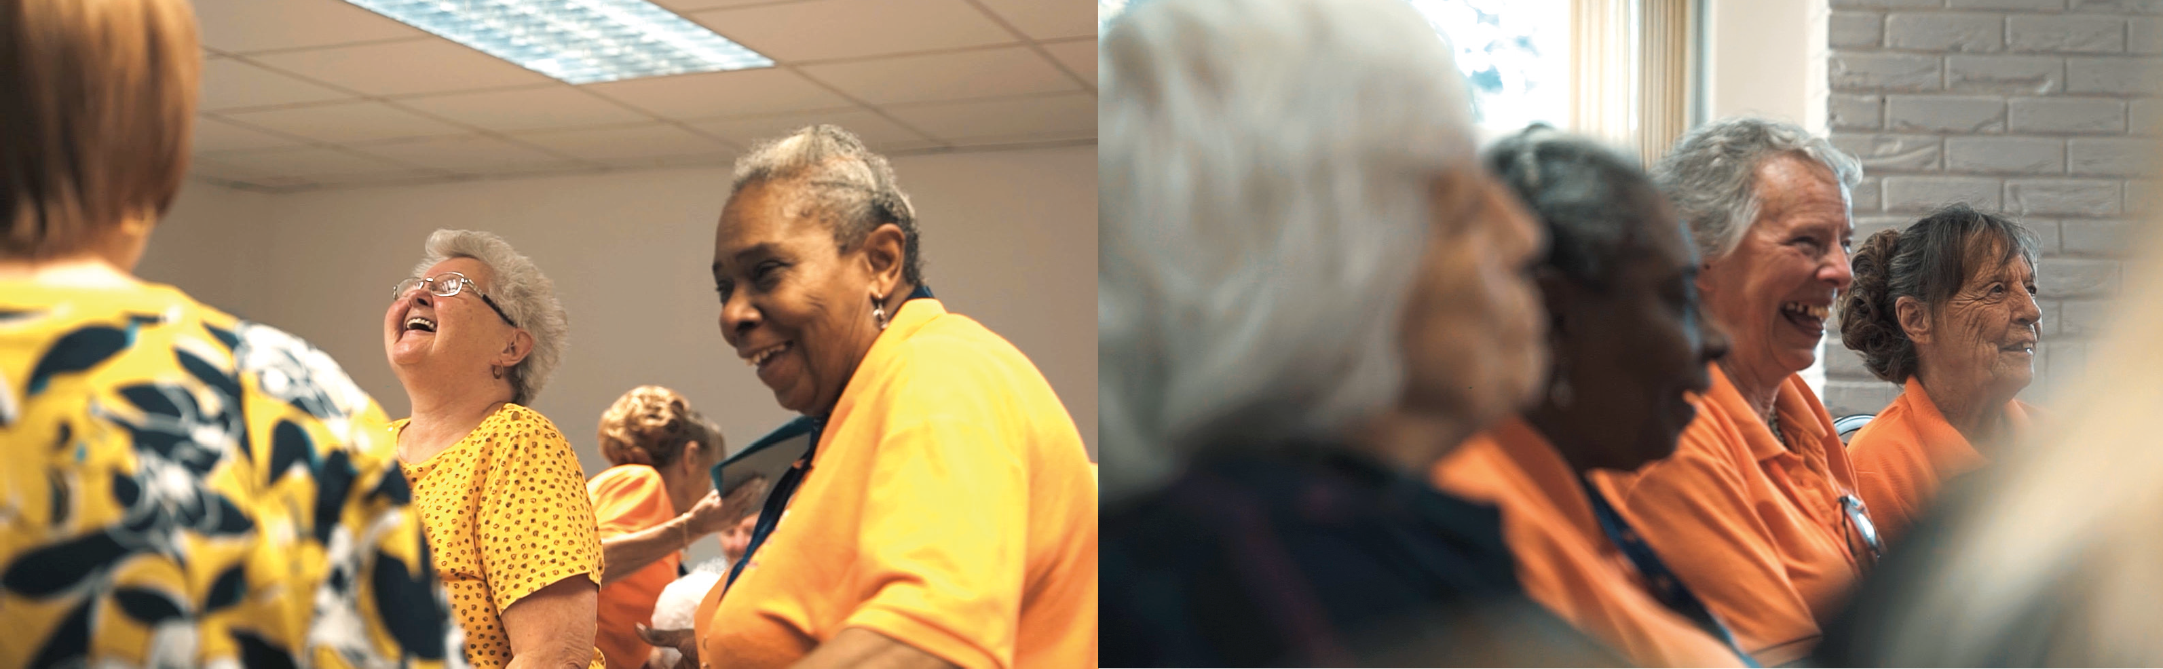

History of Bradbury Fields

Bradbury Fields was founded 168 years ago - in 1857 - by a committee of 14 women, headed by an Evangelical Protestant from a wealthy family, Mary Wainwright.

It was then called “The Society For Supplying Home Teachers And Books In Moon’s Systems Or Embossed Type To Enable The Blind To Read” – a really snappy title! The main objective was to teach blind people to read the Scriptures.

In 1861, it merged with Liverpool Workshops for the Blind in Liverpool’s Bold Street, and was renamed “The Liverpool Society for Promoting the Welfare of the Outdoor Blind”. Its aims developed to include providing employment and vocational training to blind people. By 1870 new workshops,
with classrooms, offices and a shop, had been built in Cornwallis Street.

After several name changes including “Liverpool Workshops and Home Teaching Society for the Outdoor Blind”, the organisation became known as “Liverpool Voluntary Society for the Blind” (LVSB), in 1970. This name became a problem because: our work wasn’t
just in Liverpool; it wasn’t voluntary – we employed over 20 staff, although we did have more than 100 fantastic volunteers for social activities; it wasn’t a society; it wasn’t simply for blind people, but for all those who are visually impaired.

In 2003, in recognition of hugely generous financial help from the Bradbury Foundation (HSBC’s charitable trust), we purchased our current building in Knotty Ash, and renamed it ‘The Bradbury Centre’; in 2007, our 150th anniversary, the organisation became known as ‘Bradbury Fields – services for blind and partially sighted people’.

In 2018 we were awarded ‘Freedom of the City’ of Liverpool.
In 2021, during the Covid-19 pandemic, we merged with another charity, CBI, and were
able to achieve excellent synergies, merging our sight loss services with those delivered at Christopher Grange Sight Loss Learning Hub.
In 2024 the two respective boards of trustees elected to effectively reverse the merger.
We are ‘Bradbury Fields – services for blind and partially sighted people’.


Supporting the future of Bradbury Fields

Volunteer for Bradbury Fields
Volunteers remain so important for us to achieve our charitable objectives, improving the lives of people living with sight loss across Merseyside. There are many opportunities to volunteer at Bradbury Fields so why not get in touch to find out more.

Fundraising with Bradbury Fields
© Join our lottery
© Leave a gift in your will Free Wills offer
© Challenge yourself and raise sponsorship for Bradbury Fields

Contact us

Telephone: 0151 221 0888
Email: info@bradburyfields.org.uk Website: www.bradburyfields.org.uk

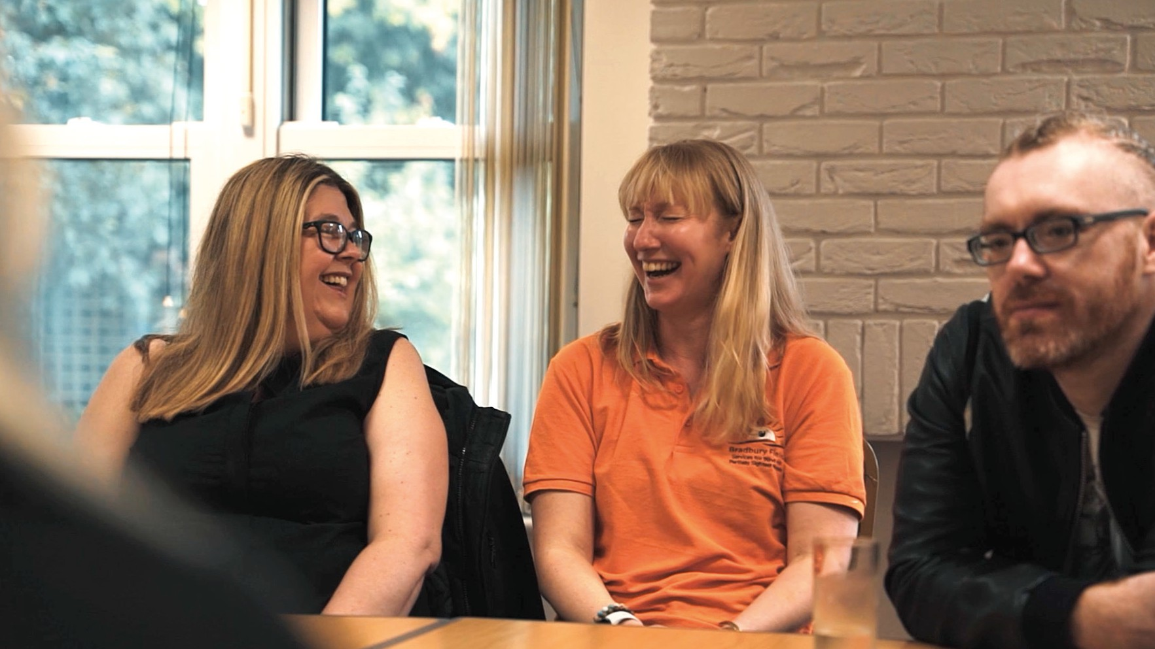







Bradbury Fields
Services for Blind
and Partially Sighted People

Telephone: 0151 221 0888
Email: info@bradburyfields.org.uk
Website: www.bradburyfields.org.uk

Registered Office:
The Bradbury Centre,
Youens Way, Liverpool, L14 2EP.

Charity number: 222798

