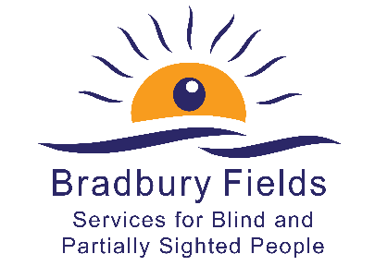

Equal Opportunities Monitoring Form

Bradbury Fields may wish to use the anonymised data to review whether they have been successful in attracting a diverse range of candidates at each stage of the process and to identify whether there is anything in the way in which the process has been conducted that has unwittingly excluded certain groups unjustifiably.

You are not required to complete this form, but it would greatly assist Bradbury Fields to monitor that their commitment to Equality, Diversity and Inclusion is being effective. This form will be detached from your application and will not be seen by the shortlisting panel.

Post applied for …………………………………………………..

Reference …………………………………………………..

Are you happy to complete this Monitoring Form?

Tick as appropriate Yes / No

1 Gender

Tick as appropriate

Male Female Non-binary Prefer not to say
Prefer to self describe ___________

2 Date of Birth
Prefer not to say

3 Ethnicity

Tick as appropriate

Asian Arab
Asian British Another ethnic group, please say what:
Bangladeshi
Chinese
Indian
Pakistani
Another Asian background, please say what:

African
Black
Black British
Caribbean
Another Black, African or Caribbean background, please say what:

Asian and White
Black African and White
Black Caribbean and White
Another mixed or multiple ethnic group, please say what:

White
White English
White Gypsy or Irish Traveller
White Irish
White Northern Irish
White Scottish
White Welsh
Other European
Another White background, please say what:

4 Disability

4a Do you have a disability, impairment or health condition which affects your day to day activities?

Tick as appropriate

Yes No Prefer not to say

If ‘yes’, please go to question 4b
If ‘no’, please go to question 5

4b If so, please provide details (optional):

4c Are there any reasonable adjustments that you feel would be necessary in order to accommodate you in this role? If so, please provide details:

5 Religious Beliefs

Tick as appropriate

No religion or belief
Buddhist
Christian
Hindu
Jewish
Muslim
Sikh
Another religion or belief, please say what:
Prefer not to say

6 Sexuality

Tick as appropriate

Asexual Pansexual
Bisexual Questioning
Gay Prefer to self describe, please say how:
Heterosexual Prefer not to say
Lesbian

7 Where did you see this advertisement?

Tick as appropriate

Job Centre
Local paper,please specify which:
National paper, please specify which:
Website, please specify which:
Other, please specify:

