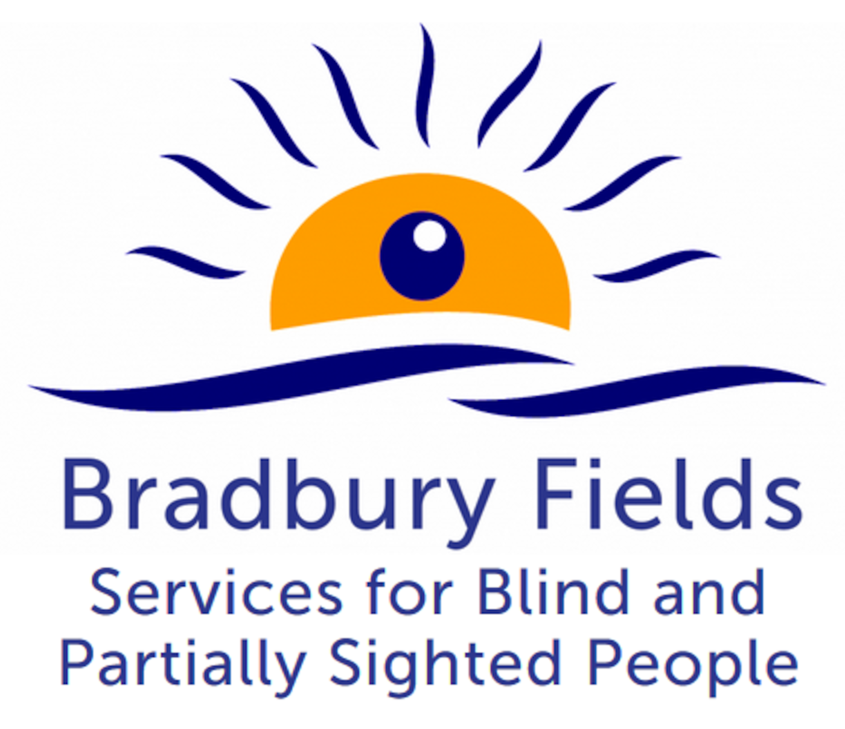

**Equal Opportunities Monitoring Form**

**Bradbury Fields may wish to use the anonymised data to review whether they have been successful in attracting a diverse range of candidates at each stage of the process and to identify whether there is anything in the way in which the process has been conducted that has unwittingly excluded certain groups unjustifiably.**

**You are not required to complete this form, but it would greatly assist Bradbury Fields to monitor that their commitment to Equality, Diversity and Inclusion is being effective. This form will be detached from your application and will not be seen by the shortlisting panel.**

Post applied for …………………………………………………..

Reference …………………………………………………..

Are you happy to complete this Monitoring Form?

Tick as appropriate Yes / No

**1 Gender**

Tick as appropriate

Male Female Non-binary Prefer not to say

Prefer to self describe ___________

**2 Date of Birth**

Prefer not to say

**3 Ethnicity**

Tick as appropriate

Asian Arab

Asian British Another ethnic group, please say what:

Bangladeshi

Chinese

Indian

Pakistani

Another Asian background, please say what:

African

Black

Black British

Caribbean

Another Black, African or Caribbean background, please say what:

Asian and White

Black African and White

Black Caribbean and White

Another mixed or multiple ethnic group, please say what:

White

White English

White Gypsy or Irish Traveller

White Irish

White Northern Irish

White Scottish

White Welsh

Other European

Another White background, please say what:

**4 Disability**

4a Do you have a disability, impairment or health condition which affects your day to day activities?

Tick as appropriate

Yes No Prefer not to say

If ‘yes’, please go to question 4b

If ‘no’, please go to question 5

4b If so, please provide details (optional):

4c Are there any reasonable adjustments that you feel would be necessary in order to accommodate you in this role? If so, please provide details:

**5 Religious Beliefs**

Tick as appropriate

No religion or belief

Buddhist

Christian

Hindu

Jewish

Muslim

Sikh

Another religion or belief, please say what:

Prefer not to say

**6 Sexuality**

Tick as appropriate

Asexual Pansexual

Bisexual Questioning

Gay Prefer to self describe, please say how:

Heterosexual Prefer not to say

Lesbian

**7 Where did you see this advertisement?**

Tick as appropriate

Job Centre

Local paper,please specify which:

National paper, please specify which:

Website, please specify which:

Other, please specify: