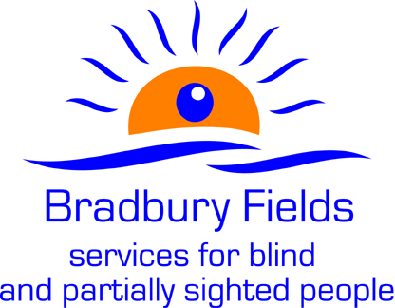

EQUAL OPPORTUNITIES
Please complete this form and return it to Maria Schofield at mschofield@bradburyfields.org.uk. The information on this form will be used for monitoring purposes only and will not be used in any decision affecting you.
All questions are optional.
All information supplied will be treated in the strictest confidence. It will not be placed on your personnel file.
Thank you for your assistance.
About the vacancy
Please state which job you have applied for and the closing date given for applications.
Job applied for: | ...................................................
Closing date for applications: | ...................................................

Where did you hear about this job (please tick)?
Newspaper (please specify) |  | Friend |  | Recruitment company
.................................

Bradbury Fields website |  | Other (please specify)
 |  | .......................................

Gender
What is your gender (please tick)?
Male
Female
Prefer not to say
(If you are undergoing gender reassignment, please use the gender identity you intend to acquire.)
Gender identity
Do you identify as transgender/transsexual?
Yes
No
Prefer not to say

Ethnic group
How would you describe your nationality and/or ethnicity (please tick)?
A  White: |  | B  Mixed race: |  | C  Asian or Asian British:
British - English, Scottish or Welsh |  | White and Black Caribbean |  | Indian
Irish |  | White and Black African |  | Pakistani
Other White background |  | White and Asian |  | Bangladeshi
 |  | Other Mixed background |  | Other Asian background

D  Black or Black British: |  | E  Chinese and other groups:
Caribbean |  | Chinese |  | Prefer not to say
African |  | Other ethnic group
Other Black background

Age
What is your age (please tick)?
16–17 |  | 18–21 |  | 22–30 |  | 31–40 |  | 41–50
51–60 |  | 61–65 |  | 66–70 |  | 71+ |  | Prefer not to say

Sexual orientation
How would you describe your sexual orientation (please tick)?
Heterosexual / straight |  | Bisexual |  | Prefer not to say
Gay man |  | Gay woman / lesbian

If you are lesbian, gay or bisexual, are you open about your sexual orientation?
 | Yes | Partially | No
At home
With colleagues
With your manager
At work generally

Religion or belief
Please describe your religion or other strongly-held belief.
I would describe my religion or belief as: | .......................................
I have no particular religion or belief
Prefer not to say

Disability
The Equality Act 2010 defines a disability as a "physical or mental impairment which has a substantial and long-term adverse effect on a person's ability to carry out normal day-to-day activities". An effect is long-term if it has lasted, or is likely to last, more than 12 months.

Do you consider that you have a disability under the Equality Act (please tick)?
Yes |  | No
Used to have a disability but have now recovered |  | Don't know
Prefer not to say

